**Experiment No.2**

**Name: Shubham Sunil Chougule.**

**Roll_no: 46**

**Div: B Batch: B2 Class: TY CSE**

**PRN: 21ST114282039**

**Title: Implement Procedures, Functions and Cursor in PL/SQL.**

**Problem statement**

1. **Implement procedures in PL/SQL.**

**1. Create a standalone procedure to display a simple message ‘Hello’.**

create or replace procedure msg

AS

BEGIN

dbms_output.put_line('Hello');

END;

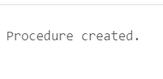

**2. Call the created procedure through a PL/SQL block.**

begin

msg;

end;

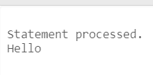

**3. Create a procedure to display a simple message ‘Hello’ inside PL/SQL block.**

Declare

procedure display

is

Begin

Dbms_output.put_line(‘Hello’;)

End;

Begin

Display;

End;

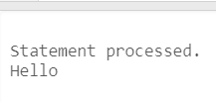

**4. Create a procedure to find square of a number using two different modes of**

**parameter passing.**

**a. IN , OUT mode**

Declare

Result number;

Procedure find_square(x in number, y out number)

Is

Begin

y:=x*x;

end;

begin

find_square(6,result);

dbms_output.put_line(‘square of a number is’||result);

end;

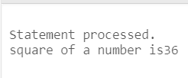

**b. IN OUT mode.**

Declare

Result number;

Procedure find_square(x in out number)

Is

Begin

x:=x*x;

end;

begin

result:=6;

find_square(result);

dbms_output.put_line(‘square of a number is’||result);

end;

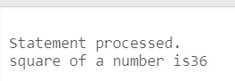

**5. Create table Student with attributes roll_no, name, address, contact_no.**

Create table student

(

roll_no number,

name varchar(20),

address varchar(20),

contact_no number(10)

);

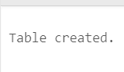

**6. Create a procedure to insert 4 values in Student table.**

Declare

procedure insert_val(

s_roll student.roll_no %type,

s_name student.name %type,

s_addr student.address %type,

s_contact student.contact_no %type

)

Is

Begin

Insert into student values(s_roll, s_name, s_addr, s_contact);

End;

Begin

insert_val(1,'Sumit','Kamble', 7234567890);

End;

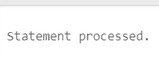

**7. Print the student table.**

Select * from student;

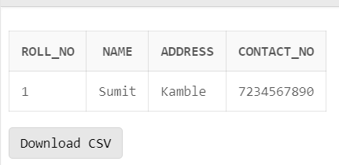

1. **Implement Functions and Cursor in PL/SQL.**

**1. Create a standalone function to display a simple message ‘Hello’.**

CREATE OR REPLACE FUNCTION msgg

return varchar2

AS

str varchar2(20);

BEGIN

str:='HELLO';

return str;

END;

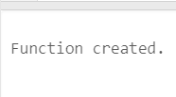

DECLARE

str1 varchar2(20);

BEGIN

str1:=msgg;

dbms_output.put_line(str1);

END;

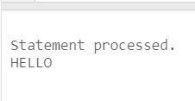

**2. Create a function to add two numbers.**

DECLARE

a number;

b number;

c number;

FUNCTION add(x IN number, y IN number)

RETURN number

IS

z number;

BEGIN

z:=x+y;

return z;

END;

BEGIN

a:=10;

b:=20;

c:=add(a,b);

dbms_output.put_line(‘Addition is:’||c);

END;

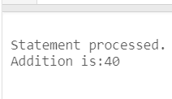

**3. Create a table ‘student’ with attributes roll_no, name, address, contact.**

CREATE TABLE student

(

roll_no number,

name varchar2(25),

address varchar2(50),

contact number(10)

);

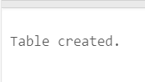

**4. Create a function to insert values inside ‘student’ table.**

**5. Insert following values in ‘student’ table using created function.**

DECLARE

a number;

function insert_val

(

s_id student.roll_no %type,

s_name student.name %type,

s_address student.address %type,

s_contact_no student.contact_no %type

)

return number

as

x number;

begin

x:=1;

insert into student values(s_id, s_name, s_address, s_contact_no);

return x;

end;

begin

a:=insert_val(1,'Sumit','pune',8746958608);

a:=insert_val(2,'Shubham','mumbai',8746958908);

a:=insert_val(3,'Yash','kolhapur',8946958608);

a:=insert_val(4,'Raj','karad',9946958608);

a:=insert_val(5,'pankaj','pune',8746058608);

end;

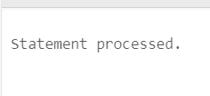

**6. Create a cursor to print all the values from ‘student’ table.**

declare

s_no student1.roll_no %type;

s_name student1.name %type;

s_address student1.address %type;

s_phn_no student1.phn_no %type;

cursor c_stud IS select roll_no, name, address, phn_no from student1;

begin

open c_stud;

loop

fetch c_stud into s_no, s_name, s_address, s_phn_no;

EXIT when c_stud %notfound;

dbms_output.put_line(s_no||' '||s_name||' '||s_address||' '||s_phn_no||' ');

End loop;

close c_stud;

end;

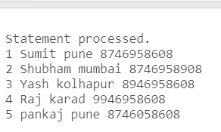

**7. Create a function to find the name of the student whose id is 2.**

declare

str2 varchar(50);

function find_name(s_id student1.roll_no %type)

return varchar

IS

s_name student1.name % type;

BEGIN

select name into s_name from student1 where roll_no=s_id;

return s_name;

END;

BEGIN

str2:=find_name(2);

dbms_output.put_line(str2);

END;

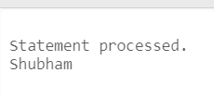

**8. Create a function to update the name of the student to ‘roma’ whose id is 4.**

DECLARE

str3 varchar(50);

function update_rec(s_id student1.roll_no %type)

return varchar

IS

s_name student1.name % type;

BEGIN

update student1 SET name='roma' where roll_no=s_id;

return s_name;

END;

BEGIN

str3:=update_rec(4);

dbms_output.put_line(str3);

END;

select * from student1;

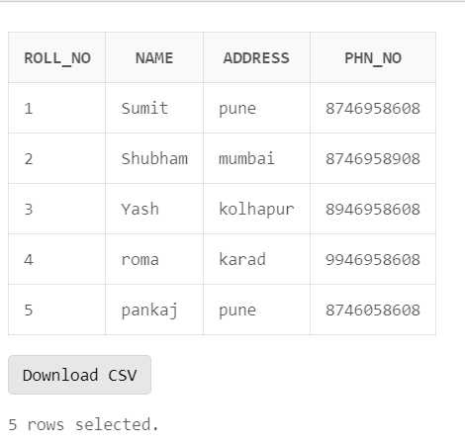

**9. Create a function to delete a record of a student whose id is 3.**

|  |  |  |  |
| --- | --- | --- | --- |
|  |  |  |  |

DECLARE

str4 varchar(50);

function delete_rec(s_id student1.roll_no %type)

return varchar

IS

s_name student1.name %type;

BEGIN

delete from student1 where roll_no=s_id;

return s_name;

END;

BEGIN

str4:=delete_rec(3);

dbms_output.put_line(str4);

END;

